Joyful Notes

October 2009

“Open Hearts. Open Minds. Open Doors”

LIFE OF OUR CHURCHES…

Astoria and Warrenton United Methodist Churches





World Communion Sunday, Oct 4
Please join us for a special worship on October 4,
World Communion Sunday. If you would be able to provide a bread from a different culture, please contact Pastor Judy. Also, you are encouraged to bring or wear something from another culture that day.
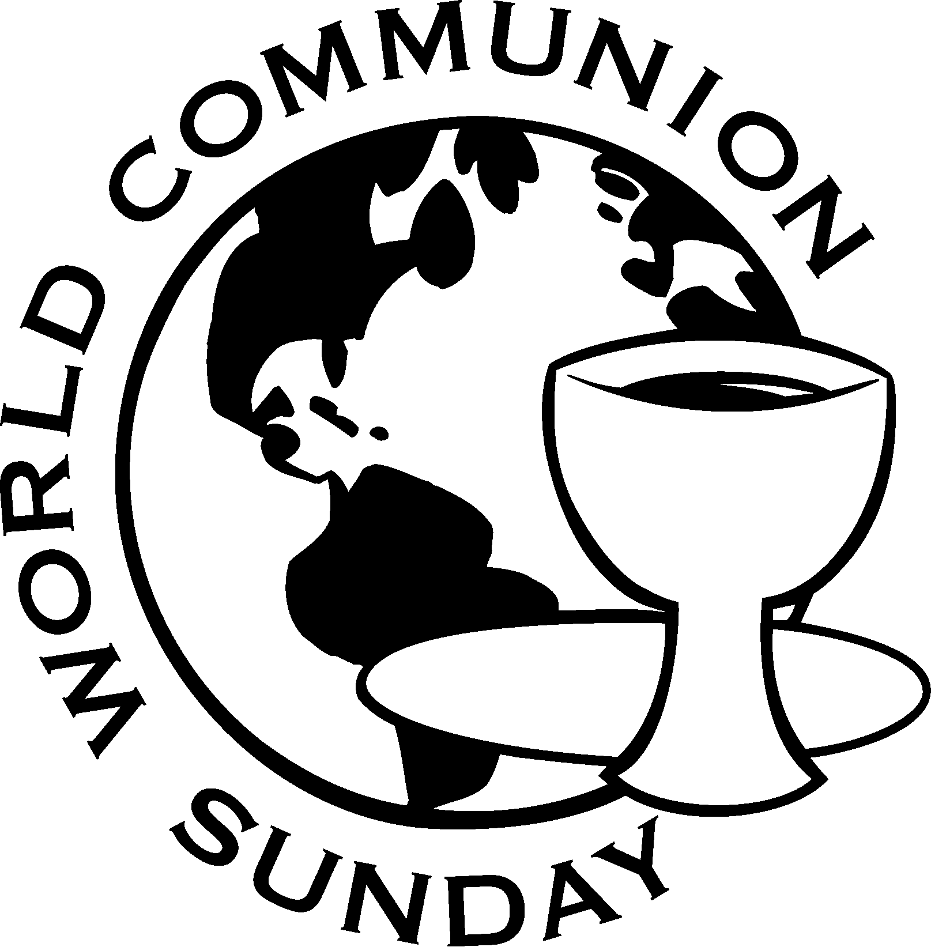

Astoria Garage Sale October 9 and 10
Bring in your clean, good quality items by October 4 for our annual fundraiser garage sale. No clothes or TV’s please.
A sign-up sheet to help set up and work a shift on the days of the sale is in the Powell-Turner Room.

You’ll remember in last month’s stewardship article that we asked for your support in all our fundraising activities by prayer, participation and inviting your friends.



Special Mission Project Our wonderful kids have decided to sell cupcakes during the garage sale as an extra fund raiser. Proceeds will be divided between the church and a mission project, Pennies for Peace. Please see an article on page two. And please support our kids, Josh, Katie, Claire, & Abbey.

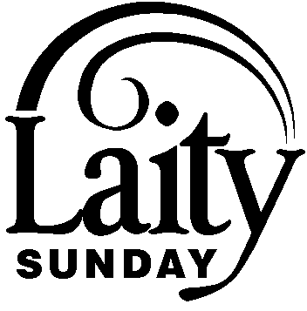
Join us Sunday, October 18 as we celebrate the blessing of you – a layman or laywoman in the church.
Please see Jane Hill or Nettie Blair if you would be willing to take part.

Astoria Halloween Breakfast Fundraiser, October 31
Plan to join your friends at breakfast, Saturday morning, 7-11,
October 31 at the Astoria church. Pancakes, eggs, ham, juice and coffee. You are invited to come in costume (or not).
Cost $5 for adults. $2 for kids under 10. Sign up to work a shift and donate food. (Remember: pray, participate, invite.)


October greetings to all of you! Over these last months I have been worshipping with a variety of congregations in our little corner of the world. From Raymond, Washington to Nehalem, Oregon, the United Methodists have been welcoming an encouraging word about our shared ministry. This litany prompts thought, reflection and enthusiasm – my prayer is that it has meaning and encouragement for each of you. Blessings, from Jane Hill.

Women: Lord, I have accepted your call to ministry; however, I do have a few concerns …One of them is that I might have to work with people who are different from me, you know, maybe a different cultural background, an unfamiliar language, or a liking for foods that are strange to me … You know, DIFFERENT. So if I am to truly be a willing and able disciple, help me to work with MY KIND OF PEOPLE.

Men: Lord, I have accepted your call to ministry, however, I am so afraid that I will let you down. I don’t have any special talents that would change the lives of others. I am not a great speaker, and I don’t know enough about the Bible to lead a Study or talk to people about God’s word. So, if I am to truly serve you, show me places and people that don’t need TOO MUCH from me – I just don’t want to learn new things and skills. Lord, help me be more confident.

Leader: Hear the word of the Lord: My beloved ones, I have called you to serve ALL my people in ALL the places they are found and in ALL the ways THEY need to share my love. Let go of your fears about differences, about lack of opportunity and about your capacity to bring my love to anyone and everyone. I have given you many gifts; not to be used so you are praised, but to be useful to others. Place your trust in my love for you.

All: Thank you Lord. Please be with us as we go to serve you by helping others. Give us Wisdom, courage, joy and peace and help us receive these blessed gifts from you. Guide us.

Leader: Hear the word of the Lord: I will walk with you in all ways and in all places. When you feel that you are faltering, I will lift you. I will give you strength and confidence. You are beloved and you are called to be with me. Receive all others as beloved and care for them as I have cared for you. Welcome the child, the stranger, the lost, lonely, alienated, hurt and angry right along with those who share joy, peace and are able to support ministry with money. Be my witnesses in the world through the service you give others in my name.

Pennies for Peace Program (P4P) educates children about the world beyond their experience and how they can make a positive impact on a global scale, one penny at a time. It teaches children the rewards of sharing and working together to bring hope and education opportunities to the children in Pakistan and Afghanistan. A penny is virtually worthless, but in impoverished countries a penny buys a pencil and opens the door to literacy.

Pennies for Peace supports the program described in the #1 New York Times Bestseller Three Cups of Tea: One Man’s Mission to Promote Peace, One School At A Time, by Greg Mortenson and David Oliver Relin. The book recounts the journey that led Greg Mortenson, Central Asia Institute co-founder, from a failed attempt to climb Pakistan’s K2 to successfully establish dozens of schools, and promote girls’ education in rural Afghanistan and Pakistan.

Josh McConnell, Katie Patterson, Claire and Abbey Albright will be selling cupcakes several times over the next few months to earn money for this project and for the Astoria church.

POET & POEMS

Rosemarie Peters Thompson is a member of the Warrenton United Methodist Church. She wrote this poem for the joint 2009 Astoria-Warrenton All Church Conference.

Sunday Morn
I attend a wee, small church,
It’s just down the street.
It’s filled with joy and happiness,
And great folks you’d like to meet.

There is a Bible Study group and
You’re free to listen in, and,
Once in awhile we have a
Pancake breakfast which surely is a treat.

The worship service is meaningful,
a smile on every face.
When we sing the well known hymns
Our voices fill this space.

Feel free to come and join us,
You’re welcome to come on in.
A Christ centered sermon is told each Sunday –
A great way for our week to begin.

Our Pastor speaks of peace and hope;
for all it’s such a joy.
The songs ring out so joyously,
on every Sunday morn.

Betty Lou Hard, daughter of Dot & Fritz Dunagan, passed away June 10, 2009. She wrote this poem.
God’s Decision
No one thinks about another ones home
Whether house or street to call his own
For many an alley is their home at nite
As they wait and pray for day lite
There was a park close by
And it was shady and inviting
As this old man stumbled along
He found a place and lowered himself
“I’ll set a spell and rest these old legs”, he said
Oh but he was very weary and
His eyes grew heavy
As he laid down across the old bench
He took a worn-out newspaper
From his pocket
And covered his tired old body.
Then he looked up to the heaven
as he said a prayer.
“May God in his wisdom make the decision
To bring me to his home up there.”
Please Pray for
- Those with health concerns: Don Morden, Diane Curs, Mary Ann Ylipelto, Lori Kindred, Irene Davis, Russell Maize, Norman Downy, Sharon Wolf, Sylvia Stephens’ daughter Kate, Laurel Nichols and her son Jerry, Joy, George Gunn, Pam Jenkins, Scott Kindred, Charlie and Nellie Hansen, Maxine Dymond, Bob Tate, Carol Boothe, Pat Kujala, Carol Clark, Waletta Kempt, Delores Hodney, Ginny Bynum, Al and Verna Davis, Priscilla and Bob Gauthier, Elizabeth Mannarino, her 5 y/o grandson Leo, Jewell Smotherman, Rose Marie Thompson and her brother, our district superintendent Kate’s mom. All who are ill.
- All who are mourning, and in particular: the family of Arlene Patterson
- Those with addictions
- People in transitions
- Pray that peace, patience, kindness, and trust in God will replace our fears and will continue to empower us to help people in need in practical ways. Pray for us to be open to the Holy Spirit.
- Pray for the people who have lost their jobs, homes, life savings, self-worth
- Our nation’s leaders
- All the men and women serving in Afghanistan and the Middle East.
- The hungry, the homeless, those in prison, those living in violence

Special People
- All who attended or prepared reports for the Joint 2009 All Church Conference.
- Allison Neussl, Don Morden and Gloria Jones for the pictures that have been shared during worship and presentations in Astoria
- Linda Grznar, our Astoria Administrative Assistant extraordinaire who organized the reports for the joint All Church Conference. A huge thank you from Pastor Judy!!!
- Bev Cox – help with the newsletters
- Diane Curs – for maintaining memorial records and Mary Lovvold who will be taking over for her
- All who contribute supplies to the church and office.
- Axel Anderson who received a BS, Cum Laude from ITT Tech in industrial auto-mation engineering technology, emphasis on robotics. He also received another honor.

Forgive me. As I sat in the pews during our worship/charge conference, I held you in my heart but should have raised my voice during the time of Prayers for Adults. I would have lifted up so many of you for what you do for the church and each other. What kind of church would we have without our UM Women and Mary/Martha Fellowship, without our Food Bank, Open Door, and Loaves & Fishes volunteers? What would we do without our UM Men, without our choir director, pianist and choir, Sunday assistants, counters and attendance keepers? How diminished we would be without our prayer chain and prayer groups, Yoga, Sunday School and Study leaders. You repair what is broken and find what is needed – humbly and joyfully – So, forgive me for not lifting you up in praise at our Church Conference – but know that you make God shine everyday in so many ways in so many places. Thank you! – Linda, your administrative assistant ☺

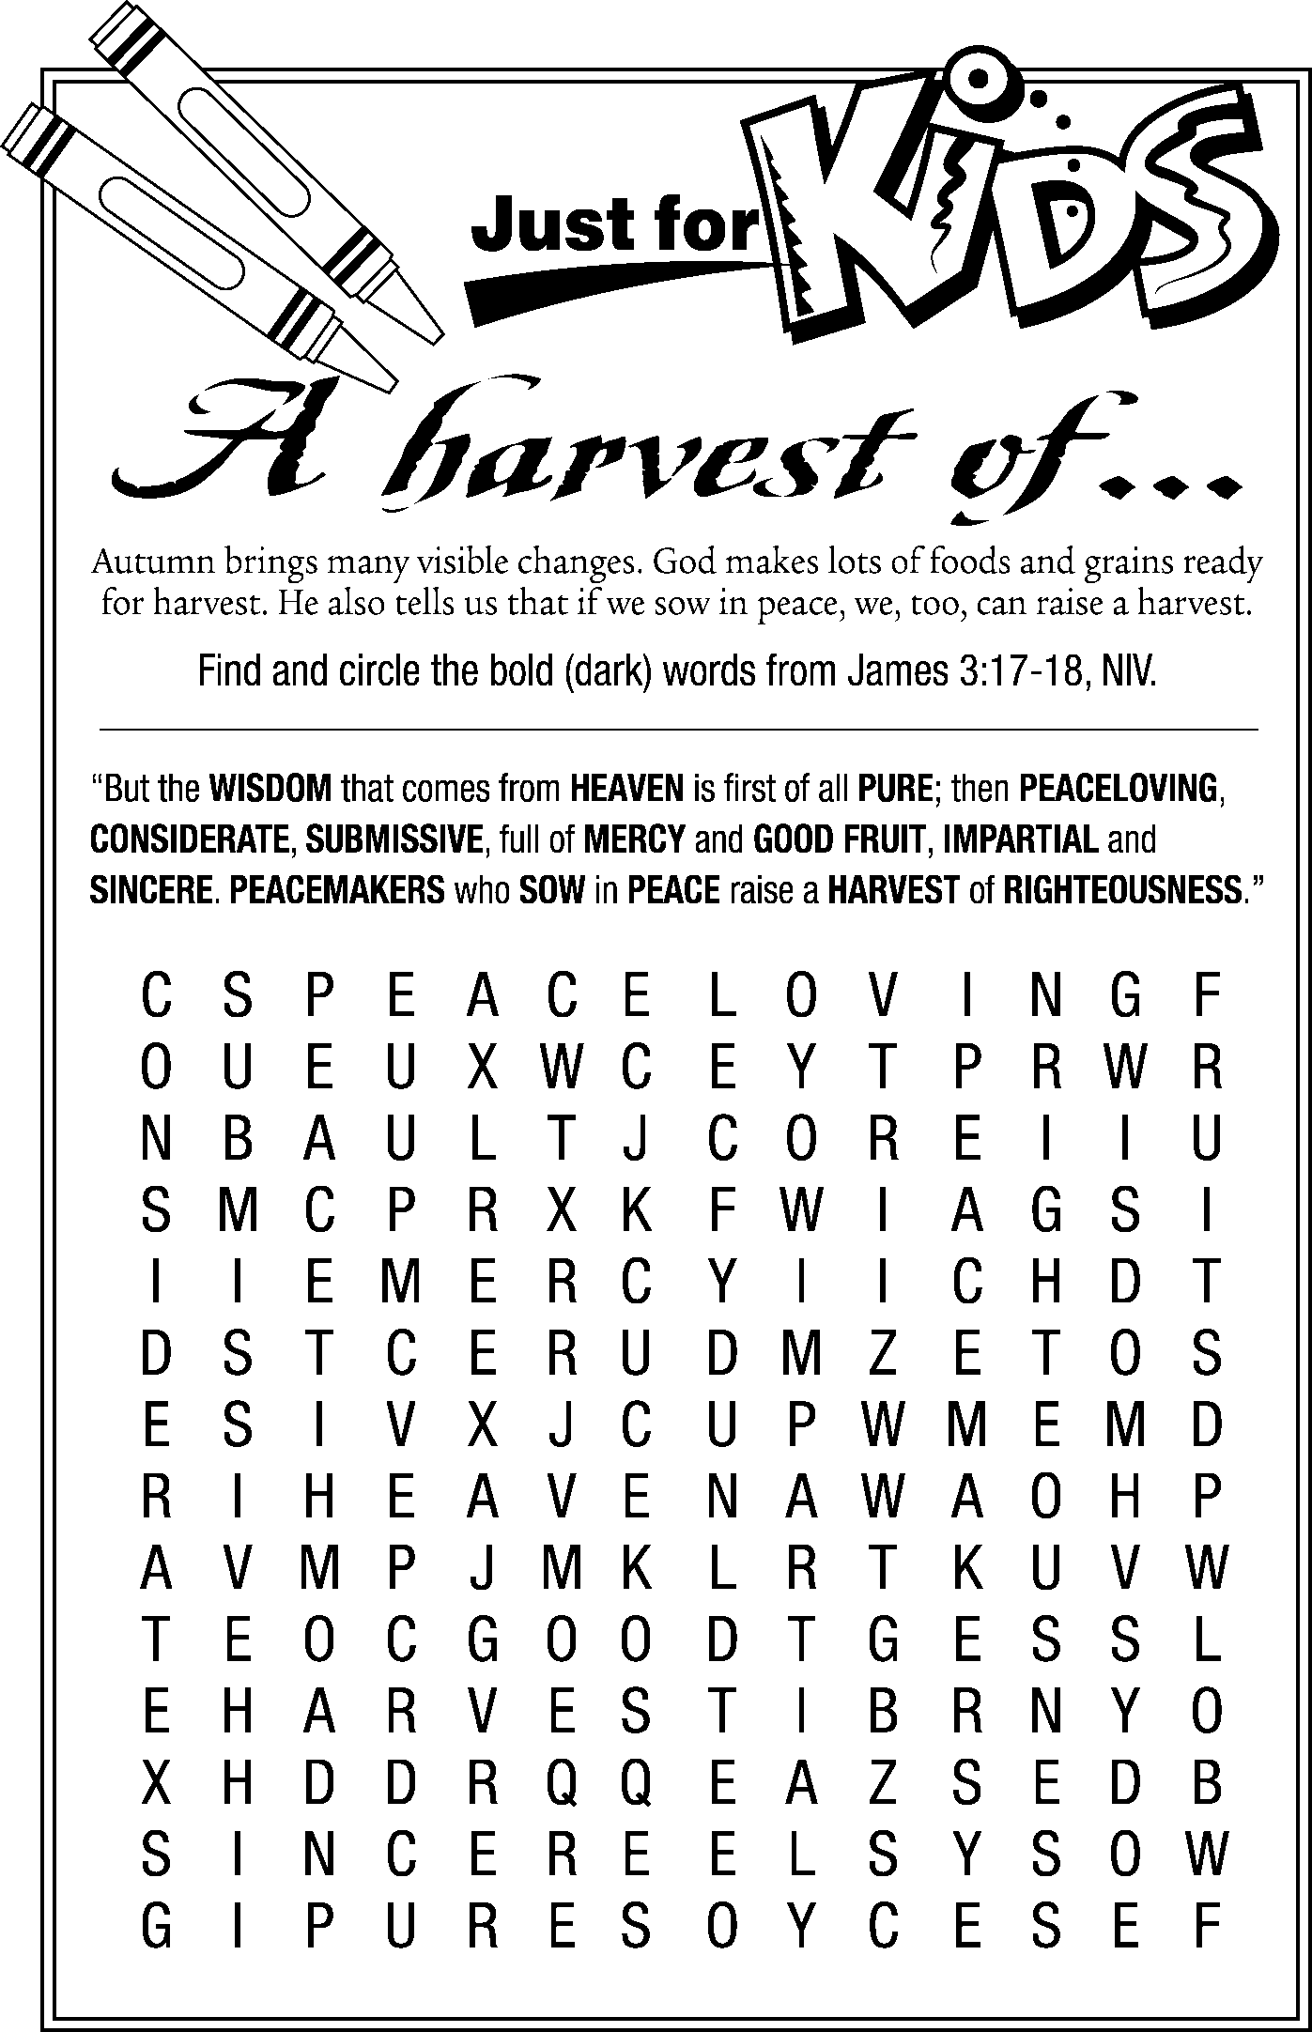

Did you know….

“Throughout their careers, clergy shall engage in continuing education for ministry, professional development, and spiritual formation and growth… The minimal quadrennial requirements shall be 70 contact hours plus 3 continuing educational units.”
UMC Book of Discipline
Attention Women:

Getting to Know You
“Getting To Know You” is the theme for the United Methodist Women’s Unit Meeting on Tuesday, October 13th at 1 p.m. in the Fellowship Hall. Program chairpersons, Anne Morden and Mary Lovvold. invite all women of the church to bring their hobbies, collections, crafts, stitchery, knitting, crocheting or sewing projects to display. Space on tables will be provided. If it is not possible to bring your entire collection, a sample will be welcome. Each person will have an opportunity to tell how they got started with these projects and why it has been a meaningful activity in their lives.

Seaside United Methodist Women invitation

Wednesday, October 14, Beryl Tindell will present a program called “Treasures” at Seaside United Methodist Church. Her husband is John Tindell, Seaside’s new pastor. There will be a potluck lunch at noon. See Anne Morden in Astoria or Laurel Nichols in Warrenton to carpool and to provide a head count for our hosts. All women are invited. Bee asks that each woman bring a photograph of something important in your life and a “Treasure.”
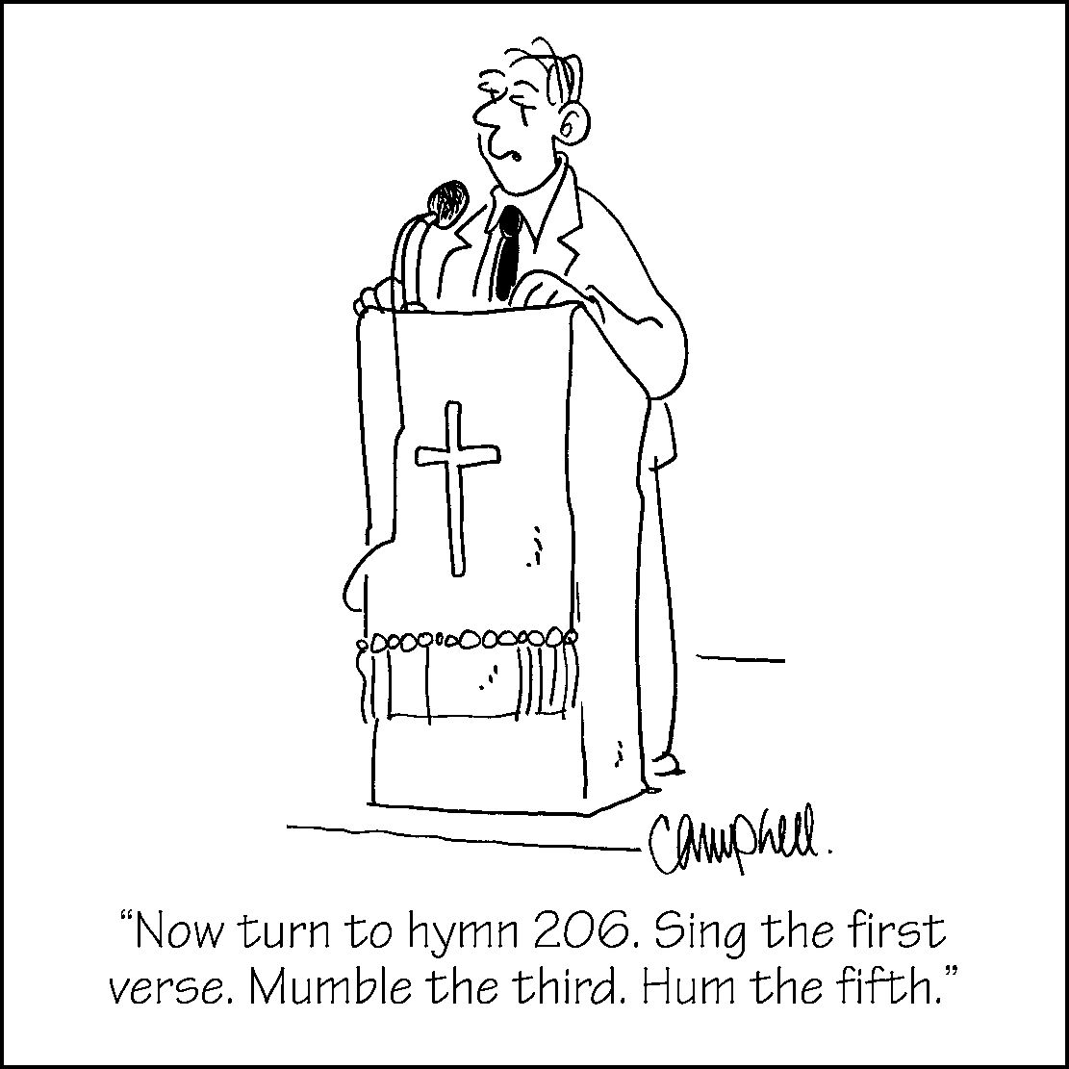
What Is Stewardship?

Stewardship is not just raising funds;
It’s raising Christians.
Stewardship is not a matter of budgets;
It’s a matter of faith.

A prayer for pumpkin people
• While cutting off the top of the pumpkin, pray, “Lord, open my mind so I can learn new things about you.” (See Proverbs 1:7.)
• While removing the seeds and pulp, pray, “Remove the things in my life that don’t please you. Forgive the wrong things I do, and help me forgive others.”
(See Matthew 6:14-15.)
• While making eyes, pray, “Open my eyes to see the beauty you’ve made in the world around me.” (See Psalm 104:24.)
• While making the nose, pray, “I’m sorry for the times I’ve turned up my nose at your many gifts.” (See James 1:17.)
• While making the mouth, pray, “Let everything I say please you.” (See Psalm 19:14.)
• While lighting the candle, pray, “Lord, help me show your light to others through the things I do.” (See Matthew 5:16.)
After carving your pumpkins, display them as examples of how God’s love transforms us into new creations. (See 2 Corinthians 5:17.)

